**Phone Data Analysis**

* Split voicemails into roughly 100 per person (each page of the email server is 100)
* Go through 1 by 1, download, and listen to them
* Fill out a spreadsheet with the following information
  + To (Find the identity it was sent to)
  + From (#, not sure if we can trace to some entity)
  + Classification?
    - Political Donation
    - Political Call-to-Action
    - Advertisement
      * For what?
    - Telemarketer
    - Junk/Nonsensical (As far as you can tell)
    - Silence
    - Malicious (IRS scam, etc)
    - Prank
  + Other things to note about the call? Okay if its “none”
* Zip up files, all .wav or .mp3, and upload to the drive, prepend ‘voicemail_ID’ to the filename
* Zip instructions: right click on folder -> send to -> zipped
* To upload to drive: subteam1/voicemail data, right click -> upload file

**Josh’s tips:**

The message duration 0:23 given here (circled in red) is usually 10 seconds longer than the actual audio file (possibly because human callers pause to hear a 10-second message before speaking). To compensate, we're asking that everyone copy/paste the length as given by "Message duration - X:XX" (i.e. you would just enter 0:23 in the spreadsheet for this example message).

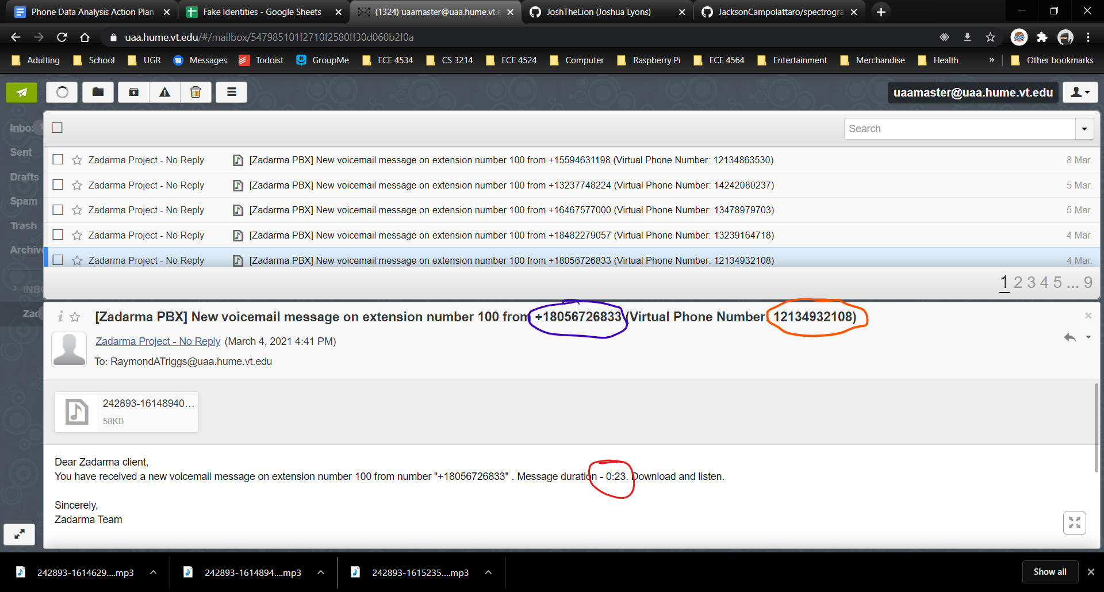

As for the other numerical fields, we're expecting y'all to simply copy/paste the circled phone numbers into the spreadsheet (there's a lookup table set to automatically fetch the associated Fake ID number when you paste the recipient's phone number).

For the example, you would enter these values into the spreadsheet

Call From: 18056726833 (circled in blue)

Call To: 12134932108 (circled in orange)

**Joe's tips:**

1. To find who it was sent to, double click the heading of the zadarma (in the section where it says "New voicemail message on extension number 100 from") Then, you need to drag select. Double clicking to grab the numbers does not work.
2. To rename a file quickly, click on your file once to have it selected, press fn f2 (near the top of your keyboard). This allows you to rename the file.
3. I typically like to first download and listen to the file, noting the contents, time, and speaker. Then, I enter those into the sheet, and then go to the zadarma page to gather the rest. This way I minimize back and forth movement.
4. There are many repeat scam messages - do not be alarmed that you are coding incorrectly. If you are ever in doubt, the sure fire way is to look at the time and date.
5. It might be worthwhile to look at how I coded a few of the voicemails to have consistency across coders.
6. Once you get into the rhythm it's not bad - you got this! Go forth and conquer!